Cactus and Succulent Society of America
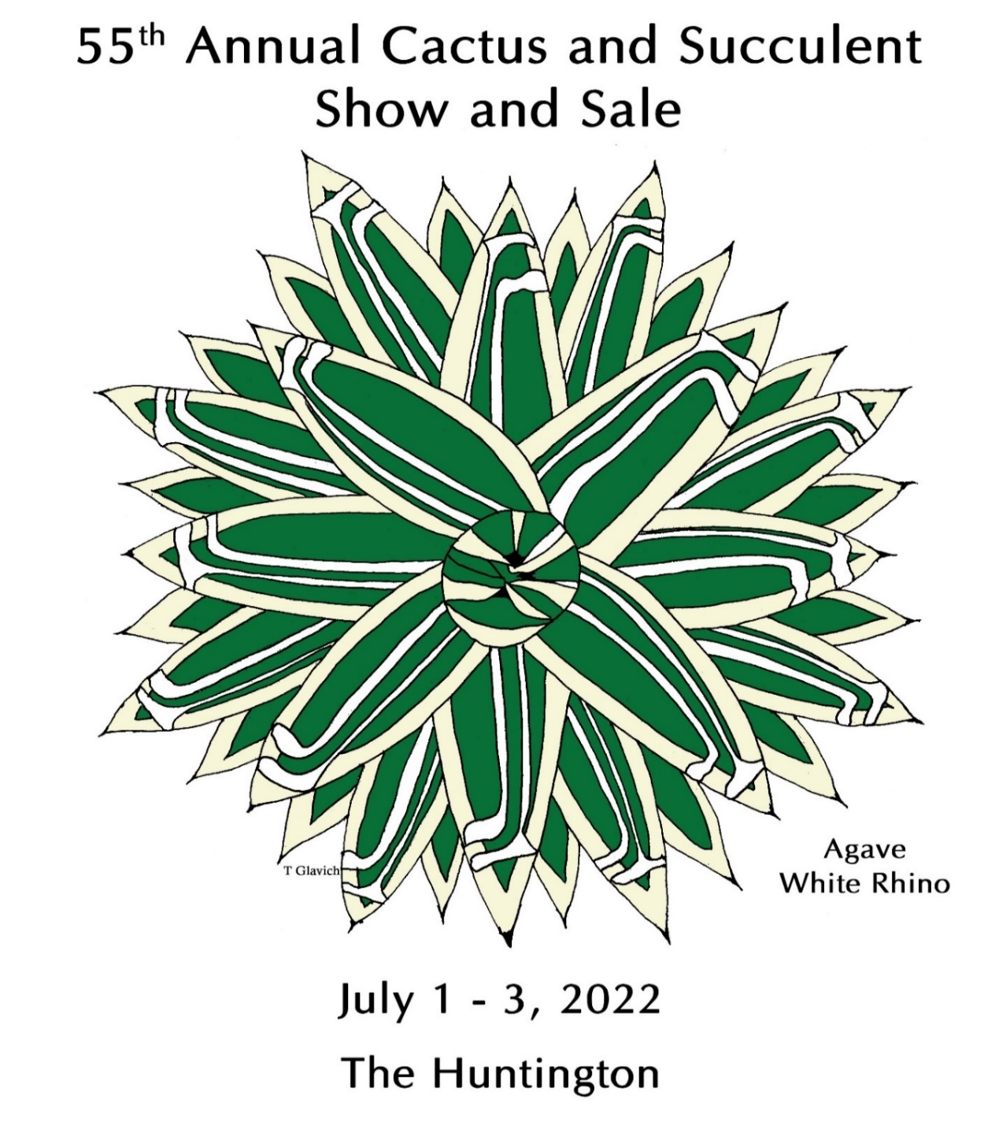
Huntington Hours 10 AM to 5 PM
1151 OXFORD ROAD, SAN MARINO, CA
INFORMATION 626-405-3504
Open to the public with paid admission or Huntington membership
Advance online timed entry reservations are now required ONLY on weekends for both visitors & Members.NO WALK-INS. Limited daily capacity. Friday sale reservations strongly recommended.
Go to the huntington.org website for tickets

See www.cssashow.com for further details.

